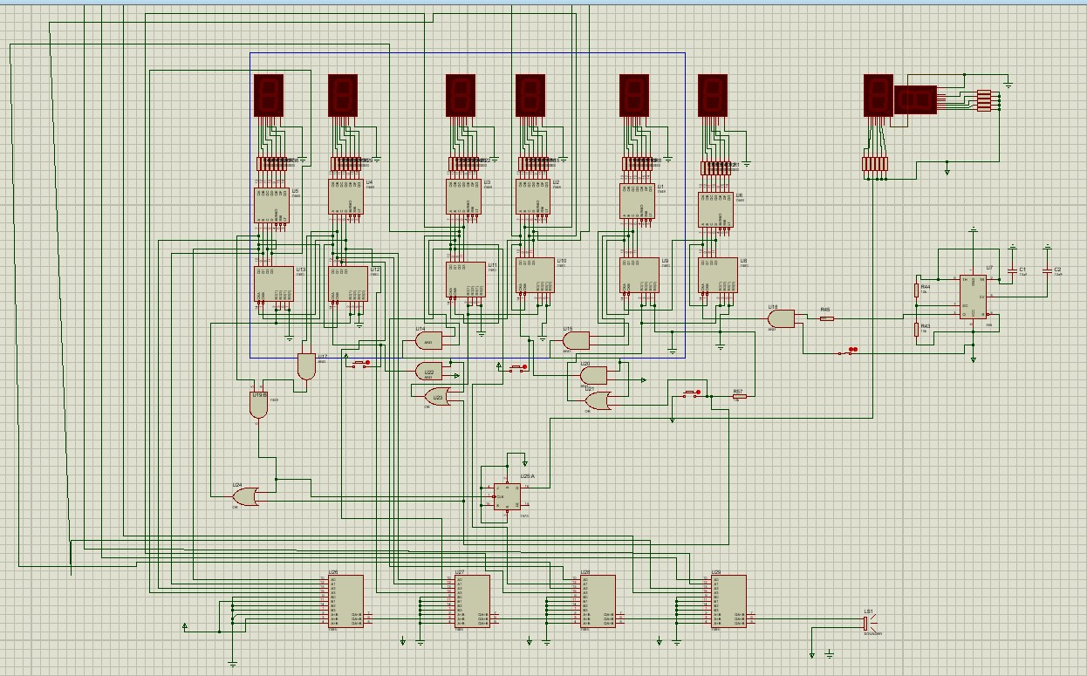

This circuit is a multi-digit digital counter with 7-segment displays. What it does:
- Counts in decimal (0 → 9)
- Displays each digit on a 7-segment display
- When one digit reaches 9, it resets to 0 and sends a carry to the next digit (like a normal digital clock or counter)
Each vertical column in your image represents ONE DIGIT.

Main Blocks in Each Digit
1. Clock / Input Pulses
- The pulses come from the bottom logic (gates + switches)
- Each pulse increments the counter by 1

- Reset & Carry Logic
  - Logic gates detect when the count = 9
  - When 1001 is detected:
o Current digit resets to 0000 o A carry pulse is sent to the next digit This is done using AND / OR gates.

- BCD to 7-Segment Decoder
  - Converts the 4-bit BCD output into 7 signals (a–g)
  - Each signal turns ON/OFF one segment of the display

- 7-Segment Display
  - Shows numbers 0–9
  - Each segment is driven through a resistor

BCD Truth Table (Core Part) Let the BCD inputs be:
A = MSB
B
C
D = LSB
Decimal A B C D
0 0 0 0 0 1 0 0 0 1
2 0 0 1 0 3 0 0 1 1
4 0 1 0 0 5 0 1 0 1
6 0 1 1 0 7 0 1 1 1
8 1 0 0 0 9 1 0 0 1

(10 → 15 are invalid in BCD and usually treated as don’t care (X))

7-Segment Truth Table (Common Cathode)
Decimal a b c d e f g
- 1 1 1 1 1 1 0
- 0 1 1 0 0 0 0
- 1 1 0 1 1 0 1
- 1 1 1 1 0 0 1
Decimal a b c d e f g
- 0 1 1 0 0 1 1
- 1 0 1 1 0 1 1
- 1 0 1 1 1 1 1
- 1 1 1 0 0 0 0
- 1 1 1 1 1 1 1
- 1 1 1 1 0 1 1

Example Karnaugh Map (Segment a) Segment a is ON for:
0,2,3,5,6,7,8,9
K-map (AB rows, CD columns)
CD
00 01 11 10
AB
- 1 0 1 1
- 0 1 1 1
11 X X X X
10 1 1 X X
Simplified Boolean Equation:
a = A + C + (B  D)
(Your exact simplification may vary depending on how you group)

Why the Circuit Is Repeated
- Each digit is identical
- Carry from one digit feeds the next
- This allows:
  - 1 digit → 0–9
  - 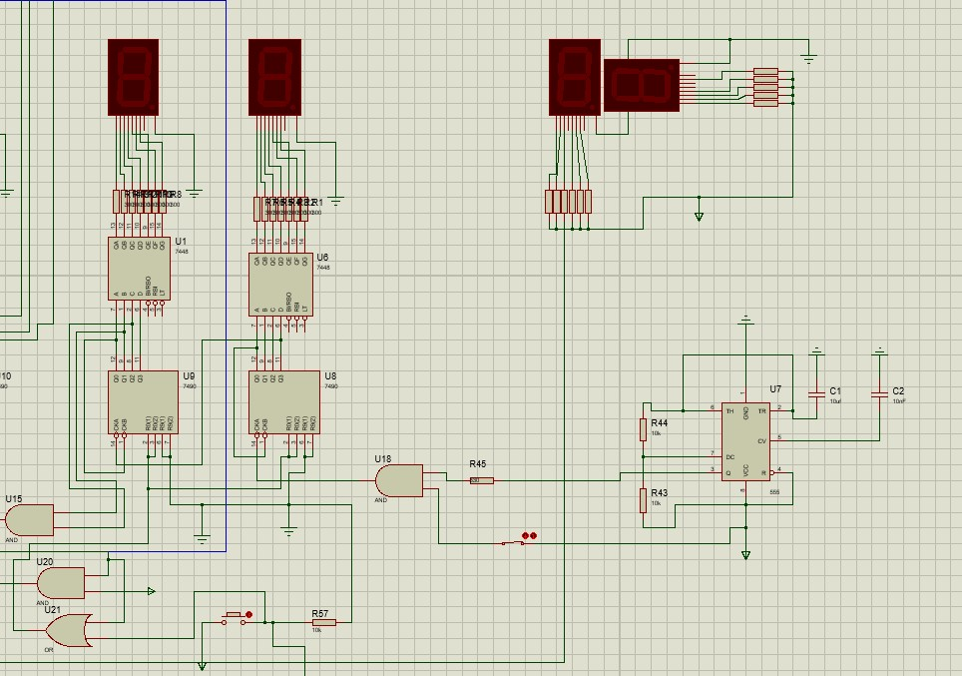
This part consists of three main sections:
- 7-segment display + resistors (top)
- BCD counter / register (4-bit output) (middle)
- Clock & control logic (gates, capacitors, switches) (bottom)
Together, this block:
- Counts from 0 to 9
- Displays the number on the 7-segment display
- Resets after 9 and sends a carry signal

Top Section: 7-Segment Display Components:
- One 7-segment display
- Current-limiting resistors
- 7 input lines (a, b, c, d, e, f, g) Function:
- Each input controls one LED segment
- If input = 1 → segment ON
- If input = 0 → segment OFF
The display does not understand binary, so it needs decoded signals.

Middle Section: BCD Output (4 Lines) This block provides 4 binary outputs:
A (MSB)
B
C
D (LSB)
These represent a BCD number:
Decimal A B C D
- 0 0 0 0
Decimal A B C D
- 0 0 0 1

2 0 0 1 0
3 0 0 1 1

4 0 1 0 0
5 0 1 0 1

6 0 1 1 0
7 0 1 1 1

8 1 0 0 0
9 1 0 0 1
1010 → 1111 are invalid in BCD

Bottom Section: Clock & Control Logic What it contains:
- Logic gates (AND / OR / NOT)
- Capacitors → debounce & pulse shaping
- Switches → manual clock or reset
- Ground & Vcc connections What it does:
- Generates a clean clock pulse
- Increments the counter by 1 each pulse
- Detects when the count = 9
- Resets the counter to 0

Reset Detection Logic (Very Important)
The number 9 in BCD = 1001 So reset condition is:
- = 1
- = 0
- = 0
- = 1
Boolean expression for RESET:
RESET = A · D · B' · C' When RESET = 1:
  - Counter goes back to 0000
  - A carry can be sent to the next digit

Truth Table (BCD → 7-Segment)
(Assuming common cathode display)
Dec A B C D a b c d e f g
- 0 0 0 0 1 1 1 1 1 1 0
- 0 0 0 1 0 1 1 0 0 0 0
- 0 0 1 0 1 1 0 1 1 0 1
- 0 0 1 1 1 1 1 1 0 0 1
Dec A B C D a b c d e f g
- 0 1 0 0 0 1 1 0 0 1 1
- 0 1 0 1 1 0 1 1 0 1 1
- 0 1 1 0 1 0 1 1 1 1 1
- 0 1 1 1 1 1 1 0 0 0 0
- 1 0 0 0 1 1 1 1 1 1 1
- 1 0 0 1 1 1 1 1 0 1 1

Karnaugh Map Example (Segment g) Segment g is ON for:
2, 3, 4, 5, 6, 8, 9
K-Map (AB rows, CD columns):
CD
AB 00 01 11 10
- 0 0 1 1
- 1 1 0 1
11 X X X X
10 1 1 X X
Simplified Boolean Expression:
g = A + (B · C) + (C · D') + (B' · C)

• Clock Signal
A 1 Hz clock pulse is generated using:
555 timer (astable), or
External clock source
Each pulse represents 1 second

- Seconds Counter
Units of Seconds (0–9)
BCD counter counts from 0000 to 1001 On reaching 9:
Counter resets to 0
Carry is sent to tens of seconds
Tens of Seconds (0–5)
- Counts from 0 to 5

- Minutes Counter (Same Logic as Seconds)
Units of Minutes (0–9)
Same BCD counter logic
Reset at 9
Tens of Minutes (0–5)
Reset at 6
- Carry sent to hours counterHours Counter (12-Hour Clock)
Units of Hours
- Counts normally using BCD
Tens of Hours
- Special logic is used to reset at 12

- Stopwatch Operation
The stopwatch uses the same counter blocks, but with different control logic. Start
- Clock pulses allowed to reach counters Stop
- Clock pulses blocked using an AND gate Reset
- All counters cleared to 0000
•
Alarm Setting
Each alarm digit is set using:
- DIP switches or toggle switches
- These switches generate a fixed BCD valu

BCD Comparator Operation
Each digit uses a 4-bit comparator, such as:
- 74LS85 (recommended)
Comparator Inputs:
- A3–A0 → Current time BCD
- B3–B0 → Alarm BCD (switches) Comparator Outputs:
- A = B → HIGH when equal
- A > B
- A < B
We use A = B ONLY

Hardware Issues
- Carry generation from 9 to 10 using AND gates may be unreliable due to propagation delay.
- OR gate–based reset logic can produce brief glitches, causing unwanted resets.
- Gate delays during reset and carry transitions may lead to incorrect counting.
- Improper power supply connections lead to IC burning.
- 7-segment displays may burn or get damaged if current-limiting resistors are not used or have wrong values.

Conclusion
The digital clock circuit was successfully designed using BCD counters, flipflops, logic gates, and 7-segment displays. The circuit accurately counts time by incrementing seconds, minutes, and hours using a 1 Hz clock signal. Each digit operates independently while transferring a carry signal to the next digit when its maximum count is reached, which ensures correct time progression similar to a real digital clock.
The BCD-to-7-segment decoder logic correctly converts binary outputs into readable decimal numbers on the displays. Reset and carry logic were effectively implemented to handle count limits such as 9 for units digits and 5 for tens digits. Overall, the project demonstrates a clear understanding of digital logic design concepts including counters, combinational logic, Karnaugh map simplification, and display interfacing. The design is modular,
reliable, and can be extended to additional digits or features such as alarms and stopwatch functionality.

